A

Project Report

On

**WORKERS HOME**

Submitted in partial fulfillment of the requirements for the award of

**DIPLOMA**

**IN**

**COMPUTER ENGINEERING**

**By**

P.SHARMILA 17001-CM-045

T.SREELEKHA 17001-CM-057

G.RAMYA SRI 17001-CM-022

CH. RAVINDHAR 17001-CM-011

P.SRIDHAR 17001-CM-048



**DEPARTMENT OF COMPUTER ENGINEERING**

**GOVERNMENT POLYTECHNIC**

MASABTANK,HYDERABAD– 500 028

TELANGANA STATE

**GOVERNMENT POLYTECHNIC**

MASABTANK, HYDERABAD – 500 028

TELANGANA STATE



**DEPARTMENT OF COMPUTER ENGINEERING**

**CERTIFICATE**

This is to certify that the Project report entitled “**WORKERS HOME” being** submitted by

P.SHARMILA 17001-CM-045

T.SREELEKHA 17001-CM-057

G.RAMYA SRI 17001-CM-022

CH. RAVINDHAR 17001-CM-011

P.SRIDHAR 17001-CM-048

In a partial fulfillment of the requirements for the award of **Diploma in Computer Engineering**, State Board of Technical Education & Training is a record of bonafide work carried out by them.

The results presented in this thesis have been verified and are found to be satisfactory.The results embodied in this thesis have not been submitted to any other Board for the award of diploma.

**Internal Guide Head of the Department**

**(Bharat Kumar M.Tech) (Sri. G.Vijay Kumar M.Tech)**

**Submitted for the viva voice examination held on____________________**

**Internal Examiner External Examiner**

**ACKNOWLEDGEMENT**

As endeavor of a long period can be successful only with the advice of my Parents and well-wishers. I now take this opportunity to express my deep gratitude and appreciation to all those who encouraged me for successful completion of the project work.

I wish to express our sincere gratitude to**Dr. S. Narsing Rao, PhD Principal**. His consistent help and encouragement to complete the project work.

My special thanks to **Sri. G Vijay Kumar M.TechHead of Computer Engineering Department, Government Polytechnic** during the process of project work for his timely suggestions and help in spite of his busy schedule.

I thankful to my guide**Mr. Bharat Kumar M.Tech,** Lecturer **inDepartment of Computer Engineering, Government Polytechnic**for this valuable guidance and suggestions in analyzing and testing throughout the period, till end of project work completion.

I also extend my thanks to the entire Teaching and Non-Teaching faculty ofGovernment Polytechnic, who have encouraged me throughout the course of Diploma in Computer Engg.

Finally yet importantly, I thank my family and all those helped me directly or indirectly for the completion of the project.

**PREFACE**

This report covers all the information about working of the project and their benefits. In the introduction chapter all the information about the project is given. This chapter also informs about the platform on which the project has been developed. Mysql chapter describes the layout and the structure of the database with their constraints and types.

PHP chapter describes the features and functionality of the Language. The features like connectivity with database and accessing the data from the database using code has explained clearly.

Requirement chapter describes the hardware requirements like Memory, Display, Storage and Processor as well as software Requirements like web browser, hosting server etc clearly.

Coding chapter describes the logic of coding has been done to implement

the Project, the code like insert, delete, retrieve, session variable to identify the current User login to book events and some more things has been explained clearly.

**INDEX**

**CONTENT Pg No**

**ABSTRACT i**

**1. INTRODUCTION 1**

1.1 WORKERS HOME

1.2 FRONTEND

1.3 BACKEND

**2. TECHNOLOGIES USED 3**

2.1 INTRODUCTION TO PHP

2.2 WORKING OF PHP

2.3 MYSQL DATABASE

2.4 APACHE SERVER

2.5 XAMPP SERVER

2.6 FEATURES OF XAMPP SERVER

2.7 BOOTSTRAP

**3. DESIGN 10**

**4.CODING 13**

**5. TESTING 30**

5.1 BLACKBOX TESTING

5.2 WHITEBOX TESTING

5.3 SOFTWARE LEVELS OF TESTING

5.4 LEVELS OF TESTING

**6. SCREENSHOTS 38**

**7. FUTURE SCOPE 43**

**8. CONCLUSION 45**

**9.BIBLIOGRAPHY**

**ABSTRACT**

As we know, every person is busy with his or her works and they do not have time to go search the workers for their requirement. Here we are introducing a website to search for the workers as per their requirement. Our website “WORKERSHOME” gives you the details of workers based on your selection. The title defines that it is a home of workers.

“WORKERSHOME” is a website where workers can register their information and details about their work and fee. It includes workers for daily requirement. It mainly includes Electrician, Carpenter, Plumber, Painter, Cleaner, Beautician and Mason. This website makes it is for those who are in search of workers.

This website made using PHP and html languages. It has a friendly user interface so that everyone can use it easily. It also has an attractive view of the web pages. The customers should login to the website to view the details of the worker. Before they have to register into the website.

**INTRODUCTION**

**INTRODUCTION**

* 1. **WORKERS HOME**

The final project of this course is the WORKERS HOME web application. Workers home is a web application, which provides the worker details. The main objective of our WORKERS HOME is to provide the details based on the requirement of the customer. By using this web application, a customer can approach the worker. By this system customer can save their valuable time and efforts.

* 1. **FRONT END**

WORKERS HOME web application developed by using HTML and CSS as front-end tools from Notepad editor. We can also use other editors like Subline text editor, brackets text editor, text mate etc.

* 1. **BACK END**

WORKERS HOME is developed by using XAMPP server. XAMPP server is a combination of PHP, Apache and MySQL. This MySQL is used organize data excepted to be retained after a program terminates by providing procedure to store, retrieve, and update as well as manage the stored data. The most important purpose of a file system is to manage user data. This includes storing, retrieving an updating data.

**TECHNOLOGIES USED**

**2.1 INTRODUCTION TO PHP:**

The PHP Hypertext Pre-processor (PHP) is a programming language that allows web developers to create dynamic content that interacts with databases.

PHP is basically used for developing web based software applications.PHP started out as a small open source project that evolved as more and more people found out how useful it was. Rasmus Lerdorf unleashed the first version of PHP way back in 1994.PHP syntax is like C.

PHP is a server side scripting language that is embedded in HTML. It is used to manage dynamic content, databases, session tracking, even build entire e-commerce sites. It was integrated with a number of popular databases, including MySQL, PostgreSQL, Oracle, Sybase, Informix and Microsoft SQL server.

MySQL server, once started ,execute even very complex queries with huge result sets in record-settings time.PHP4 added support for java and distributed object architecture(COM and CORBA),making n-tier development a possibility for the first time.

What distinguishes PHP from something like client-side JavaScript is that the code is executed on the server, generating HTML which is then sent to the client. The client would receive the results of that running that script, but would not know what the underlying code was .You can even configure your web server to process all HTML files with PHP and then there’s really no way that users can tell what you have up your sleeve.

**2.2 WORKING OF PHP:**

Server-side scripting: This is the most traditional and main target field for PHP. You need 3 things to make this work: the PHP parser (CGI or server module), a web server and a web browser. You need to run the web server, with a connected PHP installation. You can access the PHP program output with a web browser, viewing the PHP page through the server.

The PHP software works with the web server, which is a software that delivers web pages to the world. When you type a URL into your web browsers address bar, you’re sending a message to the web server at that URL, asking it to send you an HTML file. The web server responds by sending the requested file.

**WHY DOES PHP NEED A SERVER?**

Having a web server running on your local computer is not necessary for developing HTML, CSS, or most JavaScript applications. But a browser cannot interpret PHP, a local web server is essential if you want to write PHP scripts on that computer and run them without uploading them to a server somewhere.

**2.3 MYSQL DATABASE:**

MySQL is a database. The data in MySQL is stored in database objects called tables. A table is a collection of related data entries and it consists of columns and rows. Databases are useful when storing information categorically. A company may have a database with the following tables: ”Employees”, ”Customer”, ”products” and “Orders” etc.

**DATABASE CONSTRUCTION:**

MySQL databases have a standard setup. They are made up of a database, in which are contained tables. Each of these tables is quite separate and can have different fields etc. Even though it is part of one the databases. Each table contains records which are made up of fields.

**DATABASES AND LOGINS**:

The process of setting up a MYSQL database varies from host to host, you will however end up with a database name, a username and a password. This information will be required to log into the database.

**MYSQL TABLES:**

Server stores records relating to each other in a table. Different tables are created for the various groups of information. Related tables are grouped together to form a database.

**RELATIONAL DATABASE:**

Sometimes all the information of interest to a business operation can be stored in one table. SQL Server makes it easy to link the data in multiple tables. Matching an employee to the department in which they work is one example. This is what makes SQL Server a relational database management system, or RDBMS. It stores data in two or more tables and enables you to define relationships between the tables.

**DATA ABSTRACTION:**

A major purpose of a database system is to provide users with an abstract view of the data. This system hides certain details of how the data is stored and maintained. Data abstraction is divide into three levels.

**DATA TABLES:**

A database most often contains one or more tables. Each table is identified by a name (e.g. “customer or “order”).

**2.4APACHE SERVER:**

The Apache HTPP Server commonly referred to, as Apache, is a web server application notable for playing a key role in the initial growth of the World Wide Web. Apache is developed and maintained by an open community of developers under the auspices of the Apache Software Foundation. Most commonly used on a UNIX like system, the software is available for a wide variety of operating systems, including UNIX, FreeBSD, Linux, Solaris, Novell NetWare, OS X Microsoft Windows, OS/2, TPF and OpenVMS.

Released under the Apache License, Apache open-source software. As of June 2013, Apache was estimated to serve 54.2% of all active websites and 53.3% of the top server across all the domains.

Apache supports a variety of features, many implemented as compiled modules which extend the core functionality. These can range from server side programming languages support to authentication schemes. Some common language interfaces support Perl, Python, Tcl and PHP. Popular authentication modules include mod_access, mod_auth, mod_digest and mod_auth_digest, the Successor to mod_digest. A sample of other features include Secure Sockets Layer and Transport Layer Security support (mod_ssl), a proxy module (mod proxy), URL rewriter (mod rewrite), custom log files (mod_log_config), and filtering support (mod include and mod_ext_filter).

Popular compression methods on Apache include the external extension, mod grip, implemented to help with reduction of the size (weight) of web pages served over HTTP. Mod Security is an open source intrusion detection and prevention engine for web applications. Apache logs can be analyzed through a web browser using free scripts such as AWStats/W3Perl or Visitors.

Apache features configurable error messages, DBMS-based authentication databases, and content negotiation. It is also supported by several graphical user interfaces (GUIs). It supports password authentication and digital certificate authentication. Because the source code is freely available, anyone can adapt the server for specific needs, and there is a large public library of Apache add-ons.

**2.5XAMPP SERVER:**

XAMPP Server is a utility designed to allow you to create Web applications and manage your server and databases. XAMPP Server is a Windows web development environment. It allows you to create web applications with Apache2, PHP and a MySQL database. It also comes with PHPMyAdmin and SQLiteManager to easily manage your databases. XAMPP Server is the only packaged solution that will allow you to reproduce your production server. XAMPP Server installs automatically (installer), and its usage is very intuitive. Once XAMPP Server is installed, you have the possibility to add as many Apache, MySQL, and PHP releases as you want. XAMPP Server also has a tray icon to manage your server and its settings.

XAMPP is a variation of LAMP for Windows systems and it’s often installed as a software bundle (Apache, MySQL, and PHP). It is often used to serve live websites.

The most important part of the XAMPP package is Apache (or “Apache HTTP Server”) which is used run the web server within Windows. By running a local Apache web server on a Windows machine, a web developer can test web pages in a web browser without publishing them live on the Internet.

XAMPP also includes MySQL and PHP, which are two of the most common technologies used for creating dynamic websites. MySQL is a high-speed database, while PHP is a scripting language that can be used to access data from the database. By installing these two components locally, a developer can build and test a dynamic website before publishing it to a public web server.

While Apache, MySQL and PHP are open source components that can be installed individually, they are usually installed together. One popular package is called “XAMPP SERVER”, which provides a user-friendly way to install and configure the “AMP” components on window.

**2.6 FEATURES OF XAMPP SERVER:**

XAMPP is regularly updated to the latest releases of Apache, MariaDB, PHP and Perl. It also comes with a number of other modules including OpenSSL, PHPMyAdmin, MediaWiki, more.Self-contained, single instances of XAMPP can exist on a single computer, and any given instance can be copied from one computer to another. XAMPP is offered in both a full and standard version (small version).

**USAGE:**

XAMPP designers intended it for use only as development tool, to allow website designers and programmers to test their work on their own computers without any access to the internet. XAMPP has the ability to serve web pages on the World Wide Web. A special tool is provide to password protect the most important parts of package.

XAMPP also provides support for creating and manipulating databases in MariaDB and SQLite among others. Once XAMPP is installed, it is possible to treat a local host like a remote host by connecting using an FTP client.

**2.7 BOOTSTRAP:**

Boot Strapping refers to the process of loading the environment a program (or a script, in thecase of PHP) needs to operate. In the context of PHP development, it also means funnelling a web requests through a single script that perform the boot strapping process, also called “front controller”.

It is a powerful front–end framework for faster and easier web development. It includes HTML and CSS based design templates for common user interface components like Typography, Forms, Buttons, Tables, Navigation, Dropdowns, Alerts, Modals, Tabs, Accordion, Carousel and many other as well optional JavaScript extensions. Boot strap also gives you ability to create responsive layout with much less efforts.

**DESIGN**

CUSTOMER

**WORKER**

**WOKERSHOME**

**CUSTOMER:**

Register

View details

Select Worker

Login

Select category

**WORKER:**

Register

Login

View Profile

Update profile

Delete account

**S**

**CODING**

**Style.css**

nav

{

height:10vh;

background:#5b78c7;

}

.nav-links{

list-style:none;

width:50%;

height:100%;

background:lightcoral;

justify-content:space-around;

align-items:center;

margin-left:auto;

display:flex;

}

.nav-links li a{

color:white;

text-decoration:none;

font-size:16px;

}

.nav-links li a:hover{

color:#5b78c7;

}

.nav-links li a:active{

color:#5b78c7;

}

.landing{

height:90vh;

display:flex;

justify-content:center;

align-items:center;

}

.landing h1{

margin:100px;

font-size:50px;

color:#ae5fce;

}

.landing p{

margin:100px;

font-size:30px;

color:#ae5fce;

}

**Home.html:**

<!DOCTYPE html>

<html>

<head>

<link rel="stylesheet" href="style.css"/>

<title>HOME</title>

</head>

<body>

<div class="title" style="background-color:#5b78c7"><center><img src="title.png"></center></div>

<nav>

<ul class="nav-links">

<li><a href="home.html">Home</a></li>

<li><a href="ses.php">View workers</a></li>

<li><a href="worker.php">Worker Registration</a></li>

<li><a href="help.html">Help</a></li>

</ul>

</div>

</nav>

<div class="landing" style="background-image:linear-gradient(rgba(0,0,0,0.5),rgba(0,0,0,0.5)),url(background.png);background-size:cover;">

<img src="p1.webp" alt="image">

<marquee scroll="left"><h1 style="font-family:cursive;color:white;">WORKERS HOME</h1><br>

<p>A home for workers</p></marquee><img src="title.png">

</div>

</body>

</html>

**Registration form:**

**Workerreg.html**

<!DOCTYPE html>

<html>

<style>

input[type="submit"]

{

background: transparent;

border: none;

outline: none;

color: #fff;

background: #03a9f4;

padding: 10px 20px;

cursor: pointer;

border-radius: 5px;

}

</style>

<head>

<link rel="stylesheet" href="style.css">

<link rel="stylesheet" href="wreg.css">

<title>Registration</title>

</head>

<body>

<nav>

<ul class="nav-links">

<li><a href="home.html">Home</a></li>

<li><a href="ses.php">Customer</a></li>

<li><a href="worker.php">Worker</a></li>

<li><a href="help.html">Help</a></li>

</ul>

</nav>

<br>

<br>

<div class="container">

<center>

<form action="registrationw.php" method="post" enctype="multipart/form-data">

<table style="text-align:right;border=0;">

<caption><center>

<h2 style="color:#fff;"> REGISTER</h2></center>

</caption>

<tr><td><label for="cname"> Name </label></td>

<td><input type="text" name="cname" required></td></tr>

</br></br>

<tr><td><label for="Gender">Gender </label>

<br></td><td><input type="radio" name="Gender" id="Male" value="M" required><label for="Male">Male</label>

<input type="radio" name="Gender" value="F" id="Female"><label for="Female">Female</label></br></br></td></tr>

<tr><td><label for="age">Age</label></td><td><input type="Number" name="age" required></br></br></td></tr>

<tr><td><label for="email">Email </label></td><td><input type="email" name="email" required></br></br></td></tr>

<tr><td><label for="adhaar">Adhaar No</label></td><td><input type="number" minlength="16" maxlength="16" name="adhaar" required>

</br></br></td></tr>

<tr><td><label for="work"> WORK</label></td><td>

<select name="work" required>

<option value="Electrician">Electrician </option>

<option value="plumber">Plumber </option>

<option value="Painter">Painter </option>

<option value="Beautician">Beautician </option>

<option value="Mason">Mason </option>

<option value="cleaning">Cleaning </option>

<option value="carpenter">Carpenter </option>

</select>

</br></br></td></tr>

<tr><td><label for="special">Specialised for</label></td><td><input type="text" name="special" required>

</br></br></td></tr>

<tr><td><label for="experience">Experience(years)</label></td><td><input type="number" name="experience" required>

</br></br></td></tr>

<tr><td><label for="amount">Minimum Range of Amount</label></td><td><input type="number" name="amount" required></br></br>

</td></tr><tr><td><label for="address">Address</label></td><td><textarea rows="2" cols="15" name="address" required></textarea>

</br></br></td></tr>

<tr><td><label for="contact">Contact No</label></td><td><input type="Number" name="contact" required>

</br></br></td></tr>

<tr><td><label for="alt">Alternative No</label></td><td><input type="Number" name="alt" required>

</br></br></td></tr>

<tr><td><label for="username">Username</label></td><td>

<input type="text" name="username" required>

</br></br></td></tr>

<tr><td><label for="password">Password</label></td><td>

<input type="password" name="password" required>

</br></br></td></tr>

<tr><td><label for="conpassword">Confirm password</label></td><td>

<input type="password" name="conpassword">

</br></br></td></tr>

<table>

<input type="submit" value="submit">

</br></br>

</form></center>

</div>

</body>

</html>

**registrationw.php:**

<?php

$name=$_POST['cname'];

$age=$_POST['age'];

$adhaar=$_POST['adhaar'];

$gender=$_POST['Gender'];

$email=$_POST['email'];

$work=$_POST['work'];

$special=$_POST['special'];

$experience=$_POST['experience'];

$amount=$_POST['amount'];

$address=$_POST['address'];

$contact=$_POST['contact'];

$alt=$_POST['alt'];

$username=$_POST['username'];

$password=$_POST['password'];

$conpassword=$_POST['conpassword'];

$db=mysqli_connect("localhost","root","","customer");

if($db->connect_error)

{

die("connection failed:");

}

else

{

$query="insert into worker(name,gender,age,email,adhaar,work,special,experience,amount,address,contact,altnum,username,password) values('$name','$gender',$age,'$email',$adhaar,'$work','$special',$experience,$amount,'$address',$contact,$alt,'$username','$password')";

mysqli_query($db,$query);

header('location:workerl.html');

}

mysqli_close();

?>

**View details :**

<html><head>

<style>

body

{

background:url(bgpic.png);

}

table

{

text-align: right;

}

</style>

<link rel="stylesheet" href="style.css">

</head>

<body>

<nav>

<ul class="nav-links">

<li><a href="home.html">Home</a></li>

<li><a href="ses.php">Customer</a></li>

<li><a href="worker.php">Worker</a></li>

<li><a href="help.html">Help</a></li>

</ul>

</nav>

<br>

<br>

<center>

<div style="border:5px solid;width:500px;background-color:#deb887;">

<h3 style="font-family:cursive;background:#ae5f7e">Details</h3>

<?php

session_start();

if((isset($_SESSION['cusername']))&&(isset($_SESSION['cpassword'])))

{

if($_GET['id']){

$id=$_GET['id'];

$conn=mysqli_connect("localhost","root","","customer") or die("connection failed");

$rows=mysqli_query($conn,"SELECT * from worker where id=$id");

$result=mysqli_num_rows($rows);

while($arr=mysqli_fetch_array($rows))

{

echo "<table>";

echo "<tr>";

echo "<th >Name:</th>";

echo "<td>".$arr['name']."</td>";

echo "</tr>";

echo "<tr>";

echo "<th >Gender:</th>";

echo "<td>".$arr['gender']."</td>";

echo "</tr>";

echo "<th >Age:</th>";

echo "<td>".$arr['age']."</td>";

echo "</tr>";

echo "<tr>";

echo "<th >Minimum Range Amount:</th>";

echo "<td>".$arr['amount']."</td>";

echo "</tr>";

echo "<tr>";

echo "<th >Experience:</th>";

echo "<td>".$arr['experience']."</td>";

echo "</tr>";

echo "<tr>";

echo "<th >specialised for:</th>";

echo "<td>".$arr['special']."</td>";

echo "</tr>";

echo "<tr>";

echo "<th >contact:</th>";

echo "<td>".$arr['contact']."</td>";

echo "</tr>";

echo "<tr>";

echo "<th >Alternative no:</th>";

echo "<td>".$arr['altnum']."</td></tr><tr>";

echo "<th >Village:</th>";

echo "<td>".$arr['address']."</td>";

echo "</tr>";

echo "</table>";

}}

else

{

header('location:customer.html');

}

?></div>

<h4><a href="logout.php">LOGOUT</a></br></br>

<a href="profilec.php">VIEW PROFILE</a></br><img src="title.png"></h4>

<?php

}

else

{

header('location:customer.html');

}

mysqli_close();

?>

</center>

</body>

</html>

**TESTING**

**INTRODUCTION:**

Software testing is a most often used techniques for verifying and validating the quality of software. Software testing is the procedure of executing a program or system with the intent of finding faults. It is measured to be labor intensive and expensive, which accounts for >50% of the total cost of software development. Software testing is a significant activity of the software that a program does what it is intended do so. In other words, we can say it’s a process of executing a program with intends to find errors, in the language of verification and validation (V & V).

**METHODS OF TESTING:**

**1. BLACK BOX TESTING**

**2. WHITE BOX TESTING**

**5.1 BLACK BOX TESTING:**

Black box testing, also known as Behavioral Testing, is a software testing method in which the tester does not know the internal structure/design/implementation of the item being tested. These tests can be functional or non-functional, though usually functional.

The primary goal of Black box Testing is to check what functionality is performing by the system under test. This method of test can be applied virtually to every level of software testing: unit, integration, system and acceptance.

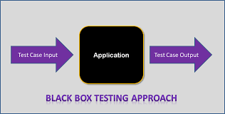

**5.2 WHITE BOX TESTING:**

White box testing is also known as Clear box testing, open box testing.White box testing is defined as the testing of a software solution’s internal structure, design and coding. In this type of testing, the code is visible to the tester. It focuses primarily on verifying the flow of inputs and outputs through the application, improving and design and usability, strengthening security.

**WORKING PROCESS OF WHITE BOX TESTING:**

* **Input:** Requirements, functional specifications, design documents, source code.
* **Processing:** Performing risk analysis for guiding through the entire process.
* **Proper test planning:** Designing test cases so as to cover entire code. Execute rinse-repeat until error-free software is reached. Also, the results are communicated.
* **Output:** Preparing final report of the entire testing process.

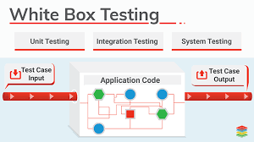

**5.3 SOFTWARE TESTING LEVELS:**

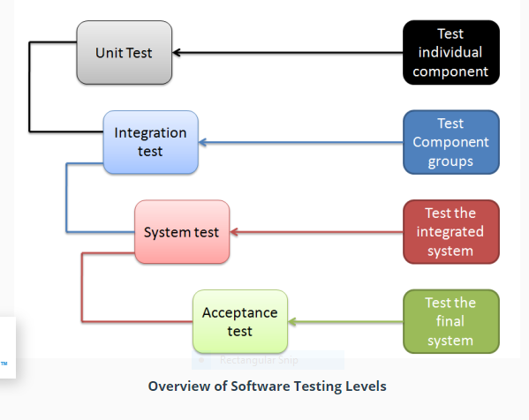

Software testing is involved in each stage of software life cycle, but the way of objectives

**5.4 LEVELS OF TESTING:**

**UNIT TESTING:** it is a code based testing which is performed by developers, this testing is mainly done to test each and individual unit separately. This unit testing can be done for small units code or generally no larger than a class.

TASKS:

* Prepare
* Review
* Rework
* Base line

**BENEFITS:**

* Unit testing increases confidence in changing/maintaining code. If good unit tests are return and if they are run every time any code is changed, we will be able to promptly catch any defects introduced due to the change.
* Codes are more reusable. In order to make unit testing possible, codes need to be modular. This means that codes are easier to reuse.
* The cost of fixing a defect detected during unit testing is lesser in comparison to that of defects detected at higher level.

**INTEGRATION TESTING:** it validates that two or more units or other integration work together properly, and inclines to focus on the interfaces specified in the low-level design.

System testing reveals that the system works end-to-end in a production like location to provide the business functions specified in the high-level design.

**BENEFITS:**

* Faster development, a confident level is high.
* Easy to integrate different modules.
* It is easy to test.
* Code coverage is high and easy to track.
* Provides major assistance in creating real time use cases.

**ACCEPTANCE TESTING:**Business owner conducts it, the purpose of acceptance testing is to test whether the system does in the fact, meet their business requirements.

**BENEFITS:**

* Reduces the risk of defects being identified in production.
* End users will gain skills and confidence while using the new system prior to go live.

**REGRESSION TESTING:** It is the testing of software after changes has been made. This testing is done to make sure that the reliability of each software release, testing had been made to ensure that changes did not introduce any new errors into the system.

**BENEFITS:**

* Regression testing increases over chance of detecting bugs caused by changes to a software and application either enhancements or defect fixes.
* It also detects undesirable side caused always by changing the operating environment.

**ALPHA TESTING** usually in the existence of the developer at the developer’s site will be done.

**BENEFITS:**

* Provides better view about the reliability of the software at an early stage.
* Helps simulate real time user behaviour and environment.
* Ability to provide detection of errors with respect to design and functionalities.

**BETA TESTING** done at the customer’s site with no developer’s in the site.

**BENEFITS:**

* Beta testing allows a company to test post-launch infrastructure.
* Improves product quality via customer feedback.
* Cost effective compared to similar data gathering methods.
* Creates good will with customer and increase customer satisfaction.

**FUNCTIONAL TESTING** is done for a finished application, this testing is to verify that it

provides all of the behaviors required.

**BENEFITS:**

* It ensures the working ofall the functionalities of an application.
* It ensures that the software works as expected.
* It ensures security and safety.
* It improves the quality of the product.

**Screenshots**

**SCREENSHOTS**

**Home page:**

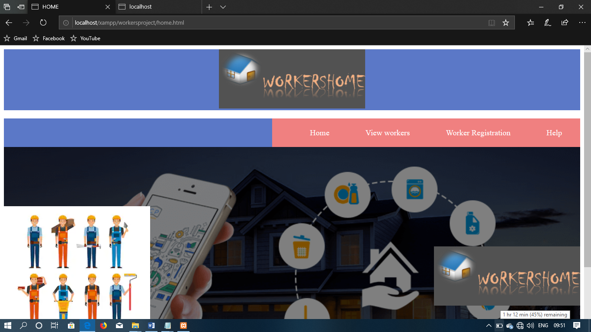

**Worker Registration form:**

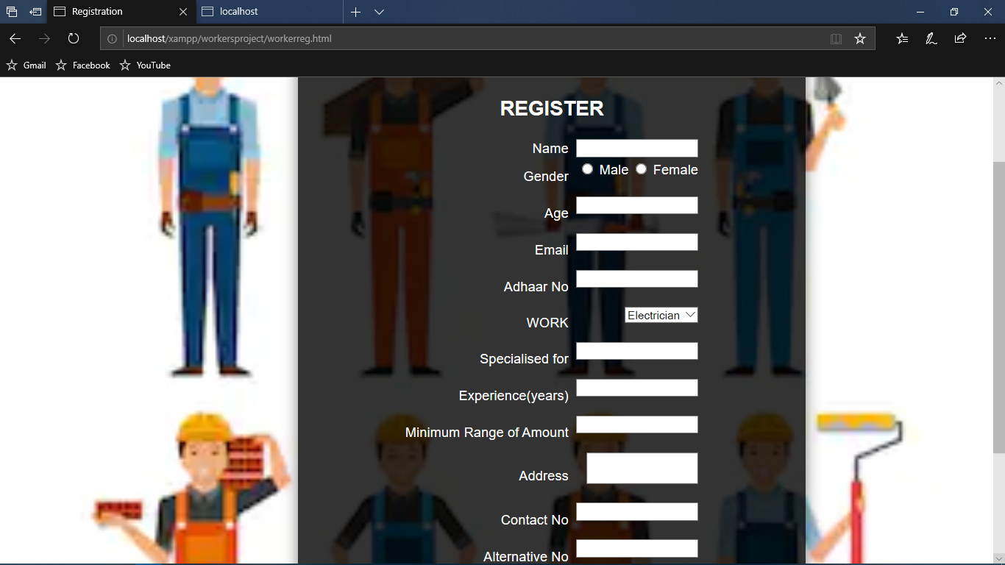

**Customer login:**

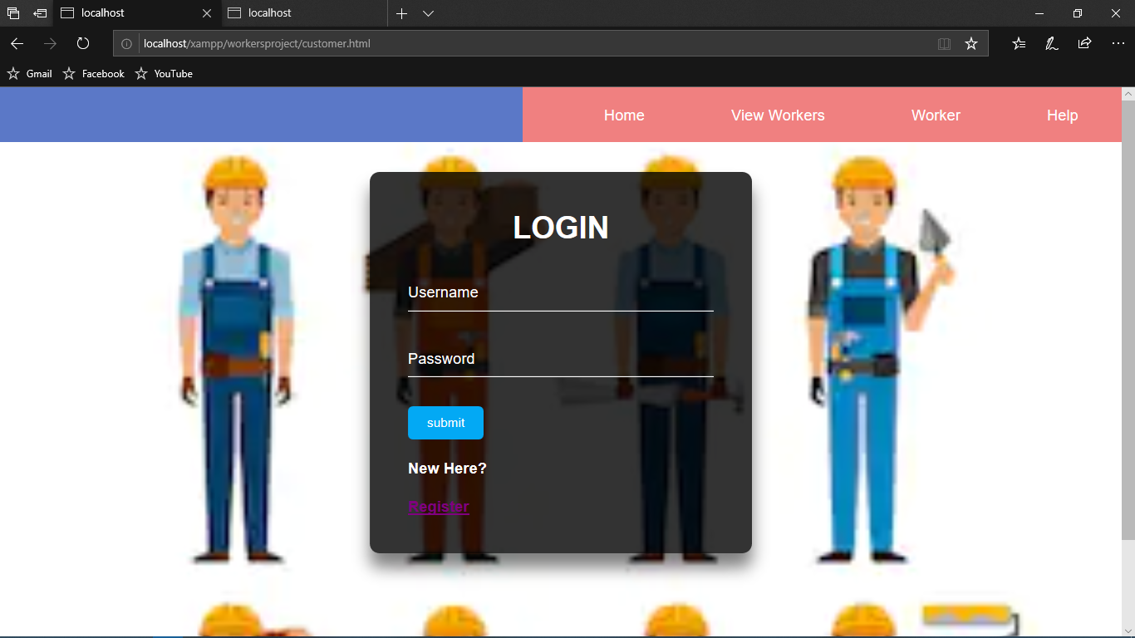

**Category selection page:**

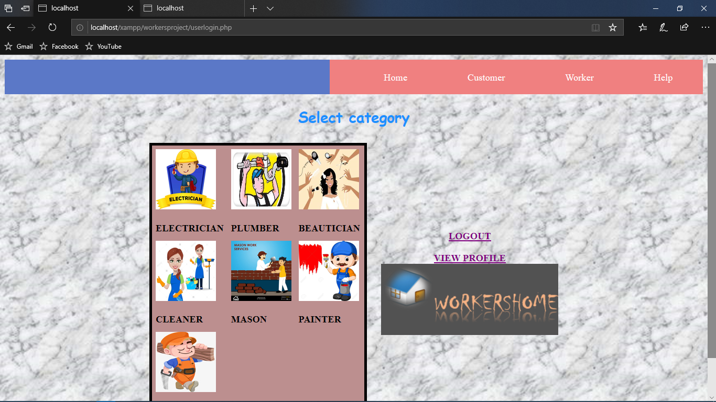

**List of workers:**

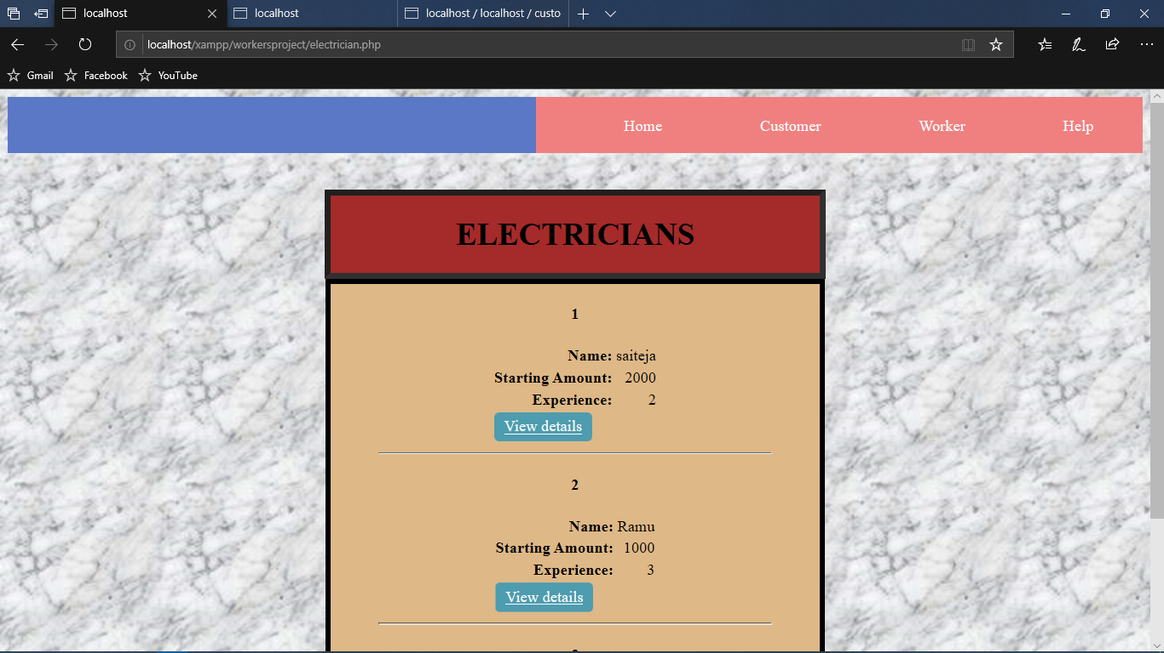

**View details:**

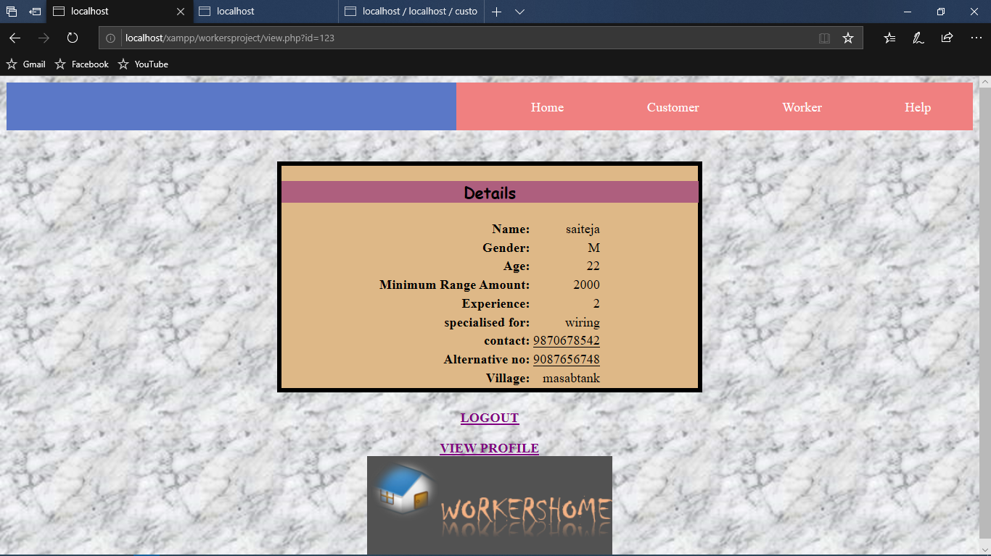

**Help.html:**

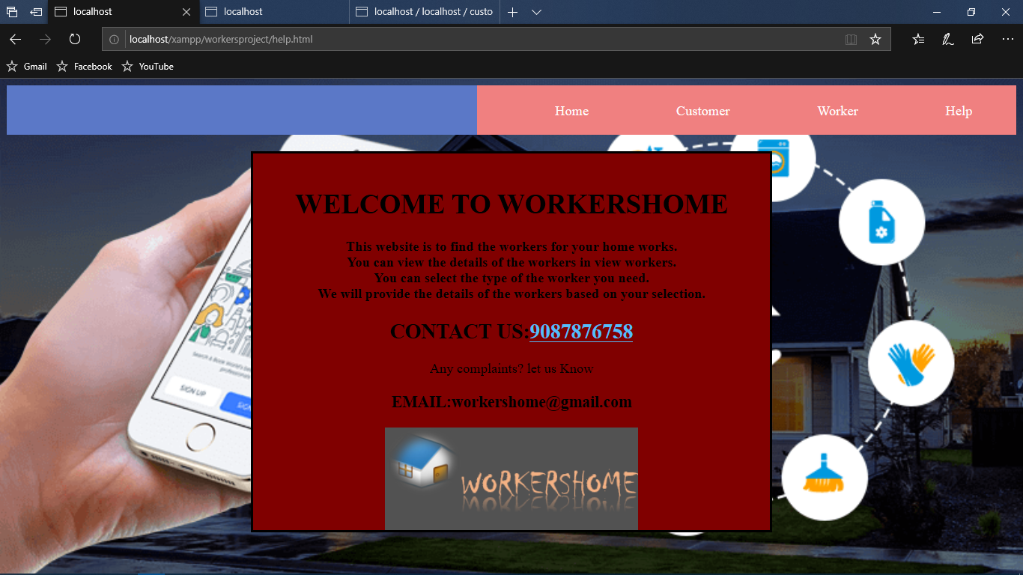

**FUTURE SCOPE**

**FUTURE SCOPE**

**India is one of the developing countries. Nowadays it is developing a lot as per technology. The aim of this project is to provide good services to the customers as per their needs and also to overcome unemployment.**

* Not a single website is ever consider as complete forever because there is always something new requirements are also growing day by day.
* We want to improve our home page, as it is the main thingwhich attracts all users.
* With the use of GPS every technician can get advance map-of-route to be followed during journey. Making a mobile app for the technician is also afirst step development.
* The future of this field is only going to increase and there will be goodnumber of opportunities as well.
* Bill payment will be included in future enhancement of our project.

**CONCLUSION**

**CONCLUSION**

From a paper analysis of positive points and constraints on the component it can be concluded that the product is highly efficient GUI based component.This application is working properly and meeting the requirements of the user. This can be easily plugged in many other computers having the windows operating system and XAMPPserver. It has been thoroughly tested and implemented. The project is user friendly approach.

**BIBLIOGRAPHY**

**BIBLIOGRAPHY**

**Web Reference:**

1. www.stackoverflow.com debugging code.
2. www.codepen.com - styling code.
3. www.tutorialspoint.com
4. Pdfs tor HTML, CSS, PHP.
5. www.solutionscone.com -database connectivity video tutorials.
6. www.colorhex.com -for html color-code.